CLoud spanner - global relational storage (managed)

Horizontally scalable global database .

When we need strong consistency and users are across multiple regions \.

An instance of Spanner is actually a set of virtual machines that are running the Spanner database.

Now, the other thing I need to do is specify the number of nodes.

Now three is the minimum number of nodes that Google recommends for a production Spanner instance.

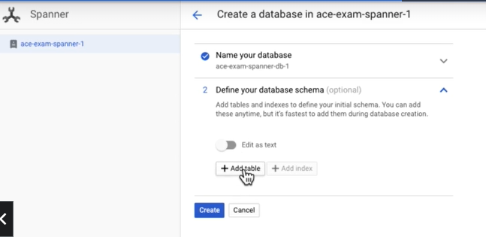

We can create spanner and create database table in that . we use scripts to do that .

Cloud Spanner does use SQL for a query language, but it is designed to horizontally scale relational transaction processing systems.